Week 4_ 3. spring-rest-handson
HandsOn_1. Display Employee List and Edit Employee form using RESTful Web Service
EmployeeController.java
package com.cognizant.employee_layered_api.controller;

import com.cognizant.employee_layered_api.model.Employee;
import com.cognizant.employee_layered_api.service.EmployeeService;
import org.springframework.beans.factory.annotation.Autowired;
import org.springframework.web.bind.annotation.*;

import java.util.List;

@RestController
public class EmployeeController {

@Autowired
private EmployeeService employeeService;

@GetMapping("/employees")
public List<Employee> getAllEmployees() {
return employeeService.getAllEmployees();
}

@GetMapping("/employees/{id}")
public Employee getEmployeeById(@PathVariable int id) {
return employeeService.getEmployeeById(id);
}
}

EmployeeDao.java
package com.cognizant.employee_layered_api.dao;

import com.cognizant.employee_layered_api.model.Employee;
import org.springframework.stereotype.Repository;

import java.util.Arrays;
import java.util.List;

@Repository
public class EmployeeDao {

public List<Employee> getAllEmployees() {
return Arrays.asList(
new Employee(1, "John", 50000),
new Employee(2, "Emma", 60000),
new Employee(3, "Alex", 70000)
);
}

public Employee getEmployeeById(int id) {
return getAllEmployees().stream()
.filter(emp -> emp.getId() == id)
.findFirst()
.orElse(null);
}
}

Employee.java
package com.cognizant.employee_layered_api.model;

public class Employee {
private int id;
private String name;
private double salary;

// Default constructor
public Employee() {
}

// Parameterized constructor
public Employee(int id, String name, double salary) {
this.id = id;
this.name = name;
this.salary = salary;
}

// Getter and Setter for id
public int getId() {
return id;
}
public void setId(int id) {
this.id = id;
}

// Getter and Setter for name
public String getName() {
return name;
}
public void setName(String name) {
this.name = name;
}

// Getter and Setter for salary
public double getSalary() {
return salary;
}
public void setSalary(double salary) {
this.salary = salary;
}

// toString() method (optional, useful for debugging)
@Override
public String toString() {
return "Employee{" +
"id=" + id +
", name='" + name + '\'' +
", salary=" + salary +
'}';
}
}
EmployeeService.java
package com.cognizant.employee_layered_api.service;

import com.cognizant.employee_layered_api.dao.EmployeeDao;
import com.cognizant.employee_layered_api.model.Employee;
import org.springframework.beans.factory.annotation.Autowired;
import org.springframework.stereotype.Service;

import java.util.List;

@Service
public class EmployeeService {

@Autowired
private EmployeeDao employeeDao;

public List<Employee> getAllEmployees() {
return employeeDao.getAllEmployees();
}

public Employee getEmployeeById(int id) {
return employeeDao.getEmployeeById(id);
}
}
EmployeeLayeredApiApplication.java
package com.cognizant.employee_layered_api;

import org.springframework.boot.SpringApplication;
import org.springframework.boot.autoconfigure.SpringBootApplication;

@SpringBootApplication
public class EmployeeLayeredApiApplication {
public static void main(String[] args) {
SpringApplication.run(EmployeeLayeredApiApplication.class, args);
}
}
application.properties
spring.application.name=code
server.port=8088
CodeApplicationTests.java
package com.cognizant.employee_layered_api;

import org.junit.jupiter.api.Test;
import org.springframework.boot.test.context.SpringBootTest;

@SpringBootTest
class CodeApplicationTests {
@Test
void contextLoads() {
}
}
OUTPUT

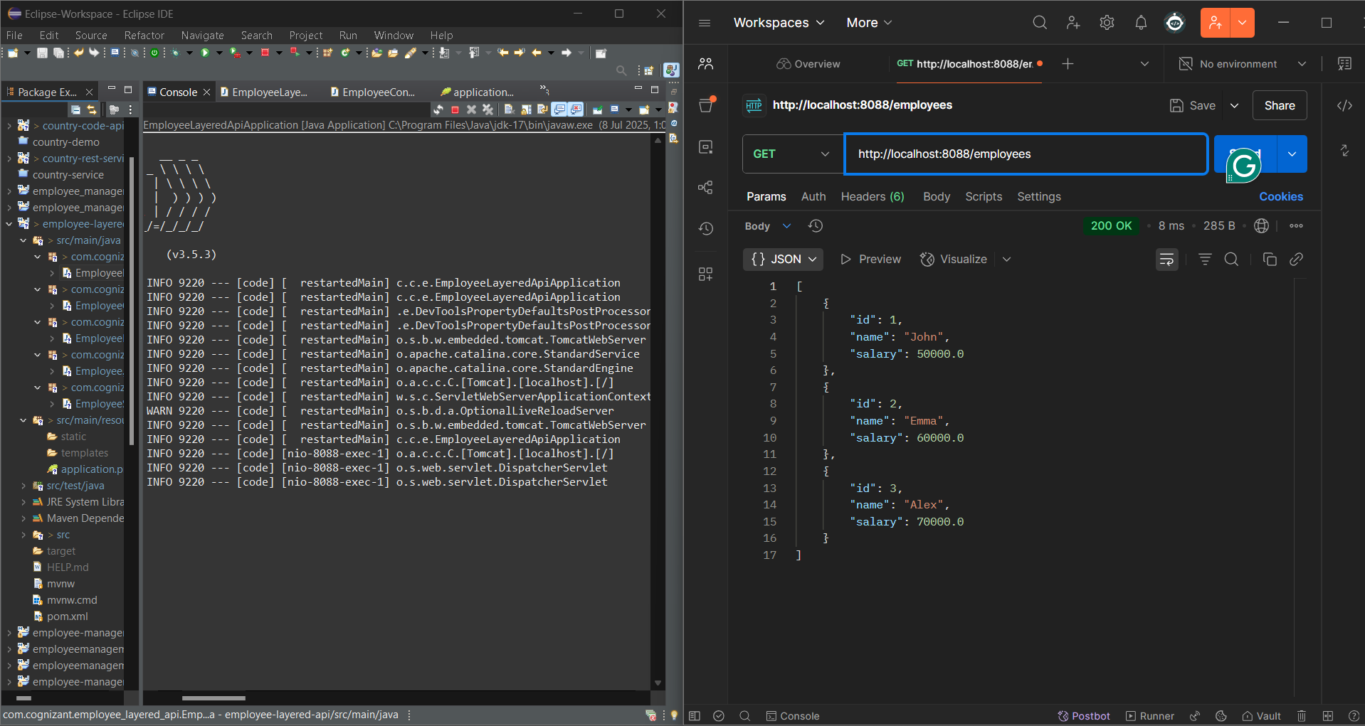
HandsOn_2. Create static employee list data using spring xml configuration
EmployeeController.java
package com.cognizant.employee_xml_config_api.controller;

import com.cognizant.employee_xml_config_api.dao.EmployeeDao;
import com.cognizant.employee_xml_config_api.model.Employee;
import org.springframework.beans.factory.annotation.Autowired;
import org.springframework.web.bind.annotation.GetMapping;
import org.springframework.web.bind.annotation.RestController;

import java.util.List;

@RestController
public class EmployeeController {

@Autowired
private EmployeeDao employeeDao;

@GetMapping("/employees")
public List<Employee> getAllEmployees() {
return employeeDao.getAllEmployees();
}
}
EmployeeDao.java
package com.cognizant.employee_xml_config_api.dao;

import com.cognizant.employee_xml_config_api.model.Employee;
import org.springframework.beans.factory.annotation.Autowired;
import org.springframework.context.ApplicationContext;
import org.springframework.stereotype.Repository;

import java.util.List;

@Repository
public class EmployeeDao {
public static List<Employee> EMPLOYEE_LIST;

@Autowired
public EmployeeDao(ApplicationContext context) {
EMPLOYEE_LIST = (List<Employee>) context.getBean("employeeList");
}

public List<Employee> getAllEmployees() {
return EMPLOYEE_LIST;
}
}
Department.java
package com.cognizant.employee_xml_config_api.model;

public class Department {
private int id;
private String name;

// Getters and Setters
public int getId() { return id; }
public void setId(int id) { this.id = id; }

public String getName() { return name; }
public void setName(String name) { this.name = name; }
}
Employee.java
package com.cognizant.employee_xml_config_api.model;

import java.util.List;

public class Employee {
private int id;
private String name;
private double salary;
private boolean permanent;
private Department department;
private List<Skill> skills;

// Getters and Setters
public int getId() { return id; }
public void setId(int id) { this.id = id; }

public String getName() { return name; }
public void setName(String name) { this.name = name; }

public double getSalary() { return salary; }
public void setSalary(double salary) { this.salary = salary; }

public boolean isPermanent() { return permanent; }
public void setPermanent(boolean permanent) { this.permanent = permanent; }

public Department getDepartment() { return department; }
public void setDepartment(Department department) { this.department = department; }

public List<Skill> getSkills() { return skills; }
public void setSkills(List<Skill> skills) { this.skills = skills; }
}
Skill.java
package com.cognizant.employee_xml_config_api.model;

public class Skill {
private int id;
private String name;

// Getters and Setters
public int getId() { return id; }
public void setId(int id) { this.id = id; }

public String getName() { return name; }
public void setName(String name) { this.name = name; }
}
EmployeeXmlConfigApiApplication.java
package com.cognizant.employee_xml_config_api;

import org.springframework.boot.SpringApplication;
import org.springframework.boot.autoconfigure.SpringBootApplication;
import org.springframework.context.annotation.ImportResource;

@SpringBootApplication
@ImportResource("classpath:employee.xml")
public class EmployeeXmlConfigApiApplication {
public static void main(String[] args) {
SpringApplication.run(EmployeeXmlConfigApiApplication.class, args);
}
}
application.properties
spring.application.name=code
server.port=8088
employee.xml
<?xml version="1.0" encoding="UTF-8"?>
<beans xmlns="http://www.springframework.org/schema/beans"
xmlns:xsi="http://www.w3.org/2001/XMLSchema-instance"
xsi:schemaLocation="http://www.springframework.org/schema/beans
http://www.springframework.org/schema/beans/spring-beans.xsd">

<bean id="dept1" class="com.cognizant.employee_xml_config_api.model.Department">
<property name="id" value="1"/>
<property name="name" value="IT"/>
</bean>

<bean id="dept2" class="com.cognizant.employee_xml_config_api.model.Department">
<property name="id" value="2"/>
<property name="name" value="HR"/>
</bean>

<bean id="skill1" class="com.cognizant.employee_xml_config_api.model.Skill">
<property name="id" value="1"/>
<property name="name" value="Java"/>
</bean>

<bean id="skill2" class="com.cognizant.employee_xml_config_api.model.Skill">
<property name="id" value="2"/>
<property name="name" value="Spring"/>
</bean>

<bean id="employee1" class="com.cognizant.employee_xml_config_api.model.Employee">
<property name="id" value="1"/>
<property name="name" value="John"/>
<property name="salary" value="50000"/>
<property name="permanent" value="true"/>
<property name="department" ref="dept1"/>
<property name="skills">
<list>
<ref bean="skill1"/>
<ref bean="skill2"/>
</list>
</property>
</bean>

<bean id="employee2" class="com.cognizant.employee_xml_config_api.model.Employee">
<property name="id" value="2"/>
<property name="name" value="Jane"/>
<property name="salary" value="60000"/>
<property name="permanent" value="false"/>
<property name="department" ref="dept2"/>
<property name="skills">
<list>
<ref bean="skill1"/>
</list>
</property>
</bean>

<bean id="employeeList" class="java.util.ArrayList">
<constructor-arg>
<list>
<ref bean="employee1"/>
<ref bean="employee2"/>
</list>
</constructor-arg>
</bean>

</beans>
OUTPUT
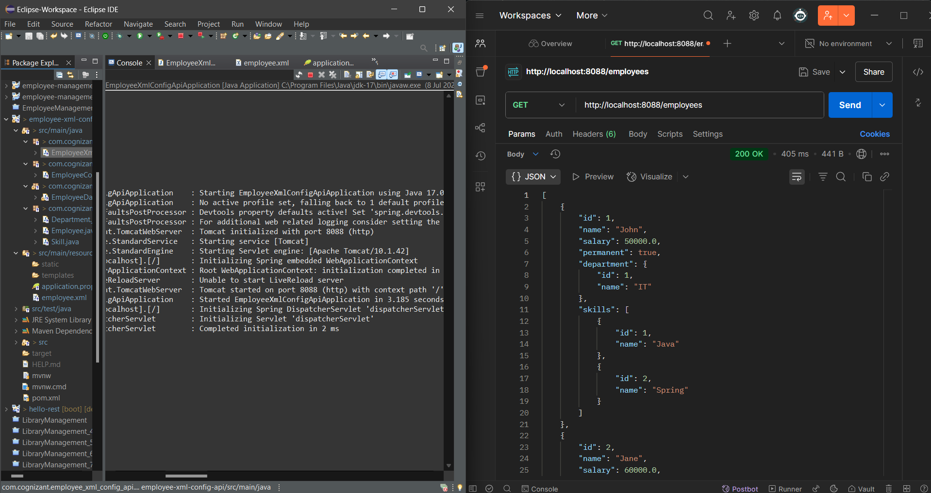

HandsOn_3. Create REST service to gets all employees
EmployeeController.java
package com.cognizant.employee_api_service.controller;

import com.cognizant.employee_api_service.model.Employee;
import com.cognizant.employee_api_service.service.EmployeeService;
import org.springframework.beans.factory.annotation.Autowired;
import org.springframework.web.bind.annotation.*;

import java.util.List;

@RestController
public class EmployeeController {

@Autowired
private EmployeeService employeeService;

@GetMapping("/employees")
public List<Employee> getAllEmployees() {
return employeeService.getAllEmployees();
}
}
EmployeeDao.java
package com.cognizant.employee_api_service.dao;

import com.cognizant.employee_api_service.model.Employee;
import org.springframework.context.ApplicationContext;
import org.springframework.context.support.ClassPathXmlApplicationContext;
import org.springframework.stereotype.Repository;

import java.util.ArrayList;

@Repository
public class EmployeeDao {
public static ArrayList<Employee> EMPLOYEE_LIST;

public EmployeeDao() {
ApplicationContext context = new ClassPathXmlApplicationContext("employee.xml");
EMPLOYEE_LIST = (ArrayList<Employee>) context.getBean("employeeList");
}

public ArrayList<Employee> getAllEmployees() {
return EMPLOYEE_LIST;
}
}
Department.java
package com.cognizant.employee_api_service.model;

public class Department {
private int id;
private String name;

// Getters and setters
public int getId() { return id; }
public void setId(int id) { this.id = id; }

public String getName() { return name; }
public void setName(String name) { this.name = name; }
}
Employee.java
package com.cognizant.employee_api_service.model;

import java.util.List;

public class Employee {
private int id;
private String name;
private double salary;
private boolean permanent;
private Department department;
private List<Skill> skills;

// Getters and setters
public int getId() { return id; }
public void setId(int id) { this.id = id; }

public String getName() { return name; }
public void setName(String name) { this.name = name; }

public double getSalary() { return salary; }
public void setSalary(double salary) { this.salary = salary; }

public boolean isPermanent() { return permanent; }
public void setPermanent(boolean permanent) { this.permanent = permanent; }

public Department getDepartment() { return department; }
public void setDepartment(Department department) { this.department = department; }

public List<Skill> getSkills() { return skills; }
public void setSkills(List<Skill> skills) { this.skills = skills; }
}
Skill.java
package com.cognizant.employee_api_service.model;

public class Skill {
private int id;
private String name;

// Getters and setters
public int getId() { return id; }
public void setId(int id) { this.id = id; }

public String getName() { return name; }
public void setName(String name) { this.name = name; }
}
EmployeeService.java
package com.cognizant.employee_api_service.service;

import com.cognizant.employee_api_service.dao.EmployeeDao;
import com.cognizant.employee_api_service.model.Employee;
import org.springframework.beans.factory.annotation.Autowired;
import org.springframework.stereotype.Service;
import org.springframework.transaction.annotation.Transactional;

import java.util.List;

@Service
public class EmployeeService {

@Autowired
private EmployeeDao employeeDao;

@Transactional
public List<Employee> getAllEmployees() {
return employeeDao.getAllEmployees();
}
}
EmployeeApiServiceApplication.java
package com.cognizant.employee_api_service;

import org.springframework.boot.SpringApplication;
import org.springframework.boot.autoconfigure.SpringBootApplication;

@SpringBootApplication
public class EmployeeApiServiceApplication {
public static void main(String[] args) {
SpringApplication.run(EmployeeApiServiceApplication.class, args);
}
}
application.properties

server.port=8088
spring.autoconfigure.exclude=org.springframework.boot.autoconfigure.jdbc.DataSourceAutoConfiguration

employee.xml
<?xml version="1.0" encoding="UTF-8"?>
<beans xmlns="http://www.springframework.org/schema/beans"
xmlns:xsi="http://www.w3.org/2001/XMLSchema-instance"
xsi:schemaLocation="http://www.springframework.org/schema/beans
http://www.springframework.org/schema/beans/spring-beans.xsd">

<!-- Sample Skill -->
<bean id="skill1" class="com.cognizant.employee_api_service.model.Skill">
<property name="id" value="1"/>
<property name="name" value="HTML"/>
</bean>

<!-- Sample Department -->
<bean id="department1" class="com.cognizant.employee_api_service.model.Department">
<property name="id" value="1"/>
<property name="name" value="IT"/>
</bean>

<!-- Sample Employee -->
<bean id="employee1" class="com.cognizant.employee_api_service.model.Employee">
<property name="id" value="1"/>
<property name="name" value="John Doe"/>
<property name="salary" value="50000"/>
<property name="permanent" value="true"/>
<property name="department" ref="department1"/>
<property name="skills">
<list>
<ref bean="skill1"/>
</list>
</property>
</bean>

<!-- Employee List -->
<bean id="employeeList" class="java.util.ArrayList">
<constructor-arg>
<list>
<ref bean="employee1"/>
<!-- Add other employees if needed -->
</list>
</constructor-arg>
</bean>

</beans>
CodeApplicationTests.java
package com.cognizant.employee_api_service;

import org.junit.jupiter.api.Test;
import org.springframework.boot.test.context.SpringBootTest;

@SpringBootTest
class CodeApplicationTests {

@Test
void contextLoads() {
}

}
OUTPUT
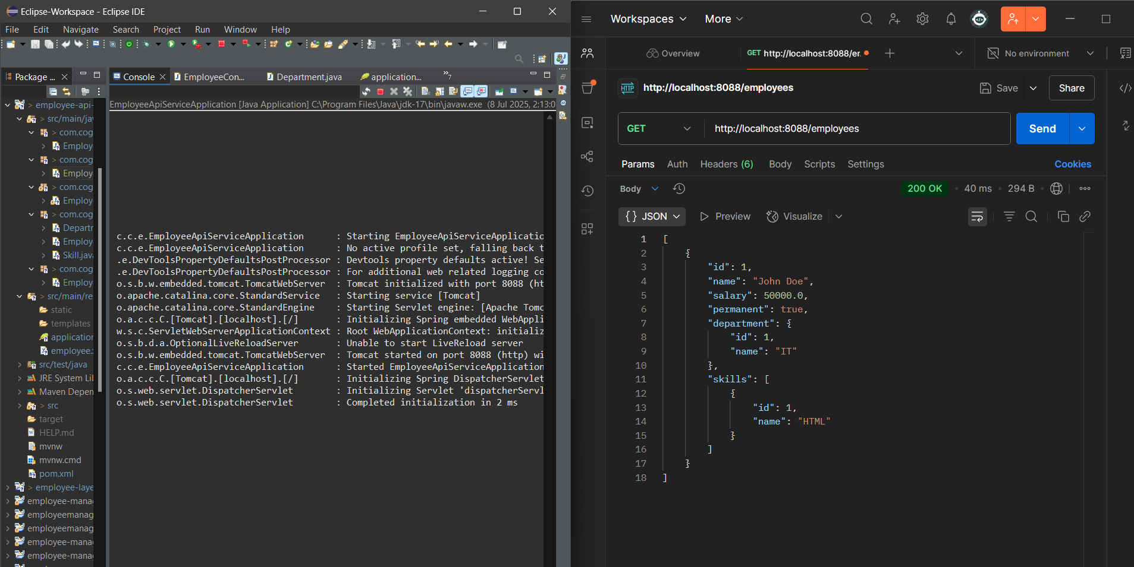
HandsOn_4. Create REST service for department
DepartmentController.java
package com.cognizant.department_api.controller;

import com.cognizant.department_api.model.Department;
import com.cognizant.department_api.service.DepartmentService;
import org.springframework.beans.factory.annotation.Autowired;
import org.springframework.web.bind.annotation.*;

import java.util.List;

@RestController
public class DepartmentController {

@Autowired
private DepartmentService departmentService;

@GetMapping("/departments")
public List<Department> getAllDepartments() {
return departmentService.getAllDepartments();
}
}
DepartmentDao.java
package com.cognizant.department_api.dao;

import com.cognizant.department_api.model.Department;
import org.springframework.context.ApplicationContext;
import org.springframework.context.support.ClassPathXmlApplicationContext;
import org.springframework.stereotype.Repository;

import java.util.List;

@Repository
public class DepartmentDao {

private static List<Department> DEPARTMENT_LIST;

static {
ApplicationContext context = new ClassPathXmlApplicationContext("department.xml");
DEPARTMENT_LIST = (List<Department>) context.getBean("departmentList");
}

public List<Department> getAllDepartments() {
return DEPARTMENT_LIST;
}
}
Department.java
package com.cognizant.department_api.model;

public class Department {
private int id;
private String name;

public Department() {}

public Department(int id, String name) {
this.id = id;
this.name = name;
}

// Getters and Setters
public int getId() { return id; }
public void setId(int id) { this.id = id; }

public String getName() { return name; }
public void setName(String name) { this.name = name; }
}
DepartmentService.java
package com.cognizant.department_api.service;

import com.cognizant.department_api.dao.DepartmentDao;
import com.cognizant.department_api.model.Department;
import org.springframework.beans.factory.annotation.Autowired;
import org.springframework.stereotype.Service;

import java.util.List;

@Service
public class DepartmentService {

@Autowired
private DepartmentDao departmentDao;

public List<Department> getAllDepartments() {
return departmentDao.getAllDepartments();
}
}
DepartmentApiApplication.java
package com.cognizant.department_api;

import org.springframework.boot.SpringApplication;
import org.springframework.boot.autoconfigure.SpringBootApplication;

@SpringBootApplication
public class DepartmentApiApplication {
public static void main(String[] args) {
SpringApplication.run(DepartmentApiApplication.class, args);
}
}
application.properties
spring.application.name=code
server.port=8088

department.xml
<?xml version="1.0" encoding="UTF-8"?>
<beans xmlns="http://www.springframework.org/schema/beans"
xmlns:xsi="http://www.w3.org/2001/XMLSchema-instance"
xsi:schemaLocation="
http://www.springframework.org/schema/beans
http://www.springframework.org/schema/beans/spring-beans.xsd">

<bean id="departmentList" class="java.util.ArrayList">
<constructor-arg>
<list>
<bean class="com.cognizant.department_api.model.Department">
<constructor-arg value="1"/>
<constructor-arg value="Human Resources"/>
</bean>
<bean class="com.cognizant.department_api.model.Department">
<constructor-arg value="2"/>
<constructor-arg value="Finance"/>
</bean>
<bean class="com.cognizant.department_api.model.Department">
<constructor-arg value="3"/>
<constructor-arg value="Technology"/>
</bean>
<bean class="com.cognizant.department_api.model.Department">
<constructor-arg value="4"/>
<constructor-arg value="Marketing"/>
</bean>
</list>
</constructor-arg>
</bean>
</beans>
CodeApplicationTests.java
package com.cognizant.department_api;

import org.junit.jupiter.api.Test;
import org.springframework.boot.test.context.SpringBootTest;

@SpringBootTest
class CodeApplicationTests {

@Test
void contextLoads() {
}

}
OUTPUT
